Amrit Singh

Dr. Weide Chang

CSC 137

10/18/18

Written Homework #2

5.13

*SUB:*

D2T4: DR <- M[AR]

D2T5: DR <- AC, AC <- DR

D2T6: AC <- complement(AC)

D2T7: DR <- AC + 1

D2T8: AC <- AC + DR, SC <- 0

*XCH:*

D3T4: DR <- M[AR]

D3T5: AC <- DR, M[AR] <- AC, SC <- 0

5.21

*Increment(PC)* = R’T1 + RT2 + D6T6(DR)’ + rB4(AC (15))’ + rB3(AC (15)) +   rB2(AC)’ + rB1(E) + pB9(FGI) + pB8(FGO)

5.22

*Write* = RT1+ D3T4 + D5T4 + D6T6

5.24

X2 is PC on BUS

X2 = R’T0 + RT0 + D5T4 = (R’ + R)T0 +D5T4 = T0 + D5T4

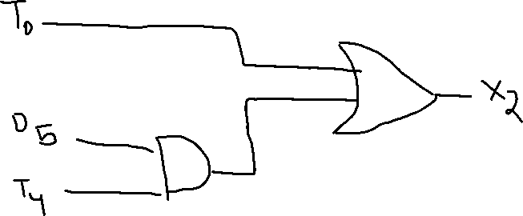

Additional Questions

1. *For the Fetch, Decode, and Indirect steps (T0 through T3) list out signals like the above. First list out signals used in Fetch, Decode, then Indirect. Then for each signal, list its timing definition. Order the listing alphabetically. (There should be 8 different signals appeared 12 times.)*

*FETCH:*

R′T0: LD(AR), x2

R′T1: LD(IR), READ, INCR(PC), x7

*DECODE:*

R′T2: DECODE (IR(12 − 14)), LD(AR), x5

*INDIRECT:*

D7 ′IT3: LD(AR), x7, READ

*DECODE:* R′T2

INCR(PC): R′T1 + RT2 + R6T6 + rB4+ rB3 + rB2 + rB1 + pB9 + pB8

= T1 + T2 + R6T6 + r (B3 + B2 + B1 + B9 + B8)

LD(AR): R′T0 + R′T2 + D7 ′IT3 = R′(T0 + T2 ) + D7 ′IT3

LD(IR): R′T1

*READ:* R′T1 + D7 ′IT3

X 2: R′T0

X 5: R′T2

X 7: R′T1 + D7 ′IT3

2. *For signals used to execute 7 different memory-reference instructions, sort them out the same way as above. First by instruction name, then by signal name. Order the listing alphabetically.*

**ADD:**

D1 T4 : LD(DR), x7 , READ

D1 T5 : LD(AC), ADD, CLR(SC)

**AND:**

D0 T4 : LD(DR), x7 , READ

D0 T5 : LD(AC), AND, CLR(SC)

**BSA:**

D5 T4 : WRITE, x2 , INC(AR)

D5 T5 : LD(PC), x1 , CLR(SC)

**BUN:**

D4 T4 : LD(PC), x1 , CLR(SC)

**ISZ:**

D6 T4 : LD(DR), x7 , READ

D6 T5 : INC(DR)

D6 T6 : E, X3 , INC(PC), CLR(SC)

**LDA:**

D2 T4 : LD(DR), x7, READ

D2 T5 : LD(AC), x3 , CLR(SC)

**STA:**

D3T4 : WRITE, x4 , INC(AR), CLR(SC)

_________________________________________________________

ADD = D1 T5

AND = D0T 5

CLR(SC) = (D0 + D1 + D2 + D5 )T5 + (D3 + D4 )T4 + D6 T6

LD(AC) = (D0 + D1 + D2 )T5

LD(DR) = (D0 + D1 + D2 + D6 )T4

LD(PC) = (T4 + T5 )D4

INC(AR) = D4 T4 + D5 T5

INC(DR) = D6 T5

INC(PC) = D6 T6

X 1 = D4 T4 + D5 T5

X 2 = D5T4

X 3 = D2 T5 + D6 T6

X 4 = D3 T4

X 7 = (D0 + D1 + D2 + D6 )T4

3. *What is interrupt-handling and why is it useful for operation of I/O devices?*

Answer:

Interrupt handling checks to see If the I/O instruction is needed. It is useful because if computers check OUTPR or INPR manually for input, it would be every millisecond, but the devices response time would be every second, which is a waste of time.